

**Course: f14/25 - description**

This event is being run on the f14/25 course.

START: on the Wrestlingworth-Guilden Morden road approx. 540 yards, south of Wrestlingworth  
 crossroads and 460 yards north of Common Farm. Proceed south to Guilden Morden where turn **LEFT** (M) 1.95 miles (2nd circuit 13.73 miles) into New Road leading to Shingay cum Wendy and Wendy to T junction 6.34 miles (2nd circuit 18.12 miles) with A1198. At junction bear **LEFT** (**CAUTION**) (M) to roundabout, where bear **LEFT** (M) onto B1042 to Tadlow and cross roads at Wrestlingworth where bear **LEFT** (M) 11.48 miles (2nd circuit 23.26 miles) on unclassified road to Guilden Morden and pass start – Repeat circuit and pass start again and in approx. 1.5 miles to: **FINISH** at south of farm entrance, 50 yards south of Water Hydrant sign and 72 yards north of Bend sign and 149 yards north of large 30 sign. (25 miles

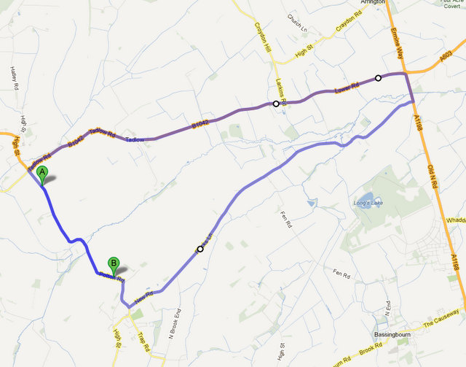

**Headquarters at Steeple Morden Village Hall  
 29, Hay Street, Steeple Morden, Royston, Herts, SG8 0PD  
 PLEASE NOTE: APROX 4 MILES TO START**

**ALLOW 20 MINS TO START POINT  
  
ALL RIDERS MUST SIGN IN AND OUT**

**OTHERWISE NO TIME WILL BE GIVEN**

**Presents**

## A 2 Up 13.7 mile and Solo 25 Mile Time Trial Event

#### 9th September 2023 Course F14/25

##### **Solo off at 14:01 2UP off at 14.41**

**Promoted under Cycling Time Trials Rules and Regulations**

###### Timekeepers: Mike Bannister, Debbie Knott

**Event Secretary: Dan Nickolay/Norma Nickolay**

**105 Ely Close**

**Stevenage**

**Herts**

**SG1 4NR**

**Home 01438 723701**

**Mobile 07770 885990**

**Headquarters address: Steeple Morden Village Hall, 15 Hay Street, Royston, Hertfordshire, SG8 0PD. PLEASE NOTE: APROX 4 MILES TO START – ALLOW 20MINS TO START POINT**

**FRONT AND REAR LIGHTS ARE OBLIGATORY.**

**NO LIGHTS NO RIDE**

Prizes

|  |  |  |  |
| --- | --- | --- | --- |
| Men’s Solo | 1st £20 | 2nd £15 | 3rd £10 |
| Ladies Solo | 1st £20 | 2nd £15 | 3rd £10 |
| 2 UP | 1st £30 | 2nd £20 | 3rd £10 |
| Road Bikes | 1st £20 | 2nd £15 | 3rd £10 |

**CASH PRIZES GIVEN ON DAY OF EVENT**

Thanks to all officials, members and friends of Stevenage CC, without whom this could not take place, and to Emily’s Tea Room Whitwell for providing refreshments.

This is a charity event in support of Stevenage Cycling Hub